Adriana
IS TURNING 6
sunday 3:30 p.m - 6:30 p.m.

15

january

the artist table
1234 nw ave. suite 123 33122 - doral, fl.

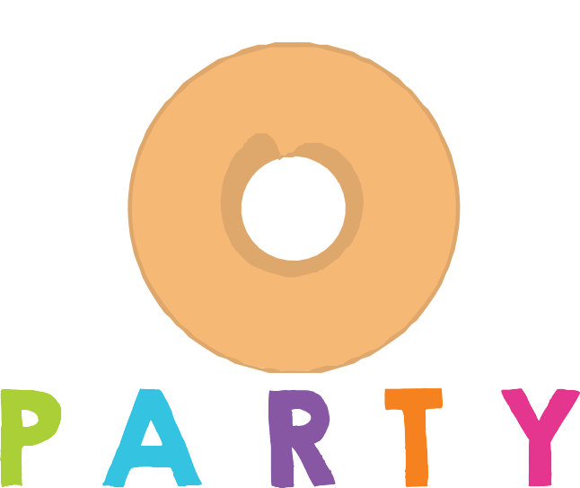rsvp. (123) 456789

